**Cascade life cycle**

This type of life cycle is Characterized by being the Most Used and one of the oldest, in Addition to being the MOST effective, it is Known by different names as a classic and traditional model, it is a Among Others That Follows cycle to STEP- by-step methodology. It develops it strictly under a hierarchy or sequence

**Stages of the life cycle**

System Engineering and Analysis: Because the software is always part of a larger system, the work Begins by Establishing the requirements of all the elements of the system and then a assigning some subset of These requirements to the software (this stage is developed When starting from a Already system developed).

Activities

* Delimitation of the scope of the project.
* Viability study.
* Risk analysis.
* Estimate.
* Temporary planning and allocation of resources.

Analysis of the requirements of the software: the process of compiling the requirements is focused and intensified especially in the software. The software engineer (Analysts) must Understand the scope of the software information, as well as the function, performance and interfaces required.

Activities

* Requirements elicitation techniques.
* Systems modeling tools.
* Requirements analysis methodologies.

Design: software design focuses on four distinct attributes of the program: data structure, software architecture, procedural detail and characterization of the interface. The design process translates requirements into a representation of the software with the required quality before coding begins.

Activities

* UML design diagrams
* Design database diagrams
* Banner design, models, navigation map etc.

Coding: the design must be translated into machine readable form. Coding step performs this task. If the design is made in detail for the encoding may be performed mechanically.

Activities

* Coding database.
* website interface site.
* developing modules.
* structuring of software modules.

Test: Once generated the code begins testing program. The test focuses on the internal logic of the software, and external functions, performing tests to ensure that defined input produces results that are actually needed.

Activities

* Unit tests
* Testing module
* System Tests
* Quality Testing

Implementation: This is the phase where the end user runs the system, for which the programmers or already conducted extensive testing to verify that the system does not fail, in addition to mount it on a website.

* Eliminate the defects detected during its lifetime (corrective maintenance), the first thing one will come to mind when you think about maintaining anything.
* Adapt to new needs (adaptive maintenance) when the system is working on a new version of the operating system or hardware in a different environment, for example.
* Add new functionality (perfective maintenance), when desirable features that would mean an improvement in the existing system are proposed.

Activities

* Selecting hosting
* mount application
* System testing.

Maintenance: the software will undergo changes after it is delivered to the customer. Changes will occur because errors have been found, the software must be adapted to changes in the external environment (operating system or peripheral devices), or because the customer requires functional or performance enhancements.

Advantage

* It is a simple method as follows intuitive steps when developing software.
* It allows a more controlled administration of the project.
* It is an effective process that serves to deliver the project in a timely manner.
* Since it is a hierarchical process allows a step is performed before finishing another.
* Helps keep the team assigned to their tasks and communication avoids confusion.

disadvantages

* The waterfall model is very flexible and does not contemplate returning to a given stage if it has to break up the stage to be changed.
* Normally, it is difficult for the client explicitly set at the beginning all requirements. The classic life cycle requires it and has difficulty in accommodating possible changes.
* The model does not contemplate the possibility of return to immediately preceding stages, which can occur in reality.

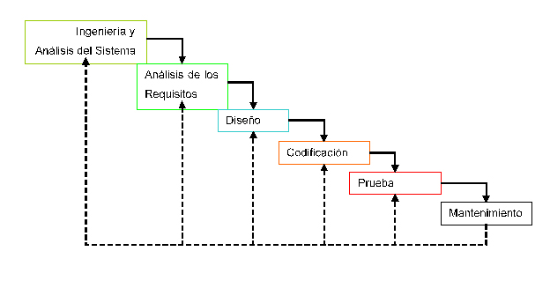

Image . Cascading lifecycle.

**Lifecycle to use**

It will use the life cycle cascaded as it is one of the most common and easy to understand besides facilitating the project because it is given more control and allows its development, and that is the safest for the project to be completed in a timely manner, because it is administered in stages and only has a forward flow, on the other hand this model lifecycle, provides stages that develop according to the progress of the project ie can not be start a task without completing another which provides controlled project forward.